To predict future financial values using a recursive algorithm based on a fixed annual growth rate in JAVA
Algorithm:Recursion
Steps:
- Take the current financial value.
- Apply the annual growth rate.
- Recursively calculate the value for the remaining years.
- Stop recursion when the number of years becomes zero.
- Display the forecasted value.
Time Complexity:O(n)
Space Complexity:O(n) due to recursive call stack.
CODE:-
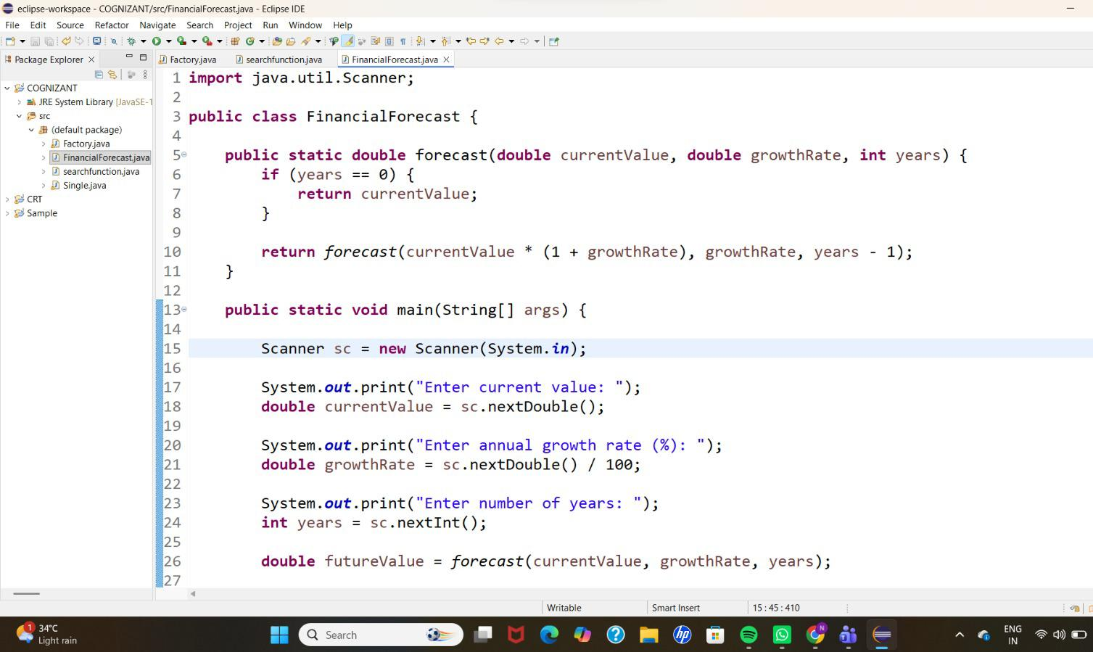
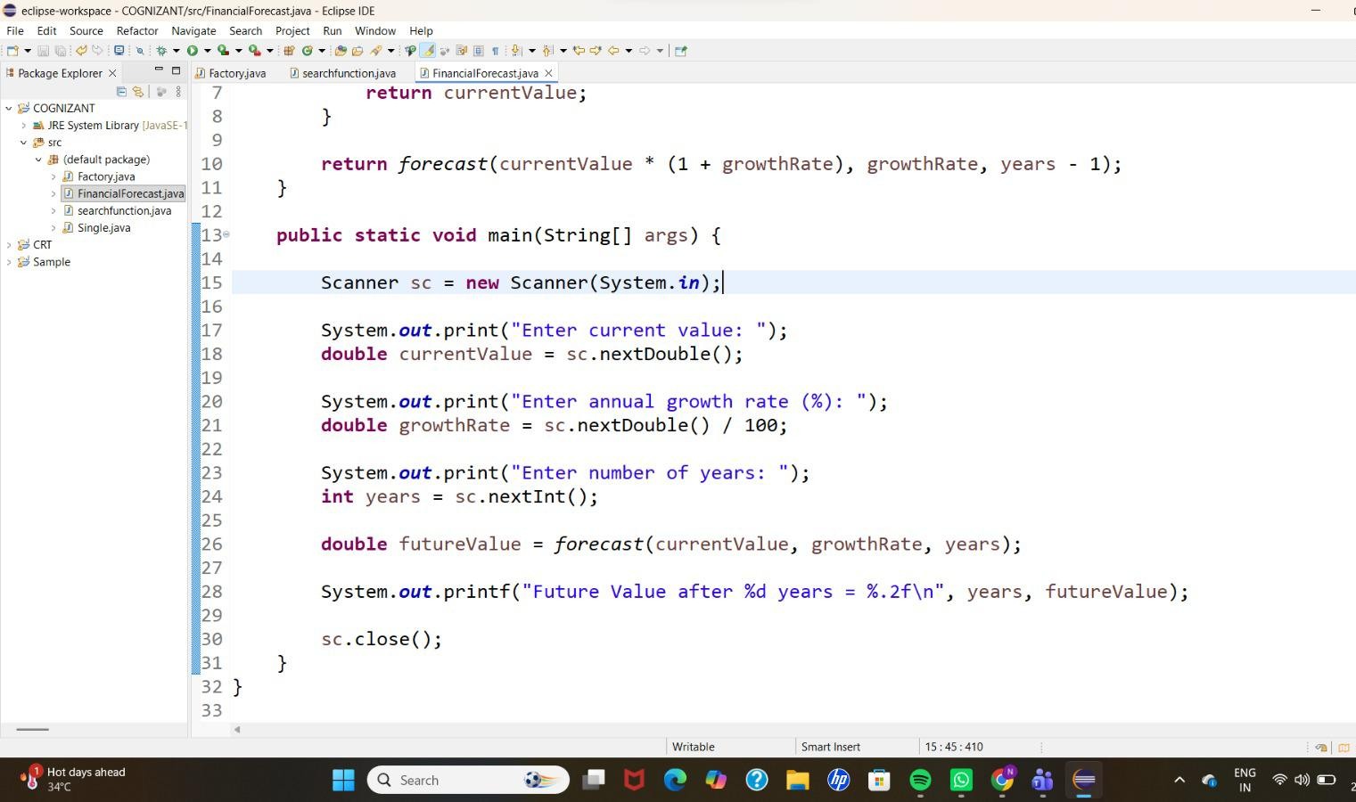
OUTPUT:-
